ENGEN DRC
COMPANY PROFILE

Engen DRC
Company Overview
Engen DRC is a subsidiary company of Engen Petroleum Limited, an Africa-based energy company focusing on the downstream refined petroleum products market and related businesses. Our core business is the refining of crude oil, the marketing of primary refined petroleum products and the provision of convenience services via an extensive retail network of over 1650 service stations. Engen also exports its products to more than 30 other territories, mostly in Africa and the Indian Ocean Islands. It is currently the market leader in South Africa, Namibia, Democratic Republic of Congo and Burundi as well as a significant player in several other key African and Indian Ocean Island markets.
Engen is owned 80% by Petronas National Berhad (Petronas), Malaysia’s national oil company and 20% by Worldwide African Investments Holdings (WAIH). Since its formation, Petronas has grown to be included on the Fortune 500 list of the world’s biggest corporations. Through this association, we have leading global support in all areas of our business, coupled with the freedom to pursue our African dream.
Core Business
Engen is in the DRC from the end of 2007 by an acquisition of the Shell assets, but has been active in the DRC through an investment in a company registered in Belgium called ARISTEA (51% Total & 49% Engen) and which operates in DRC through a company called Fina Congo.
From November 2009, the marketing assets of Fina Congo were split: Engen DRC (50%) and Total RDC (50%); which grew the market share of Engen DRC from 22% to 32% actual.
Currently ENGEN DRC owns 69 operational service stations through the country:

- Kinshasa : 39 sites
- Muanda : 1 site
- Boma : 2 sites
- Matadi : 4 sites
- Mbanza-Ngungu: 1 site
- Inkisi : 1 site
- Kasangulu : 1 site
- Kikwit : 1 site
- Bandundu : 1 site
- Mbandaka : 1 site
- Kisangani : 3 sites
- Bunia : 1 site
- Butembo : 1 site
- Goma : 1 site
- Bukavu : 3 sites
- Lubumbashi : 4 sites
- Likasi : 1 site
- Kolwezi : 1 site
- Mbuji-Mayi : 1 site
- Kananga : 1 site

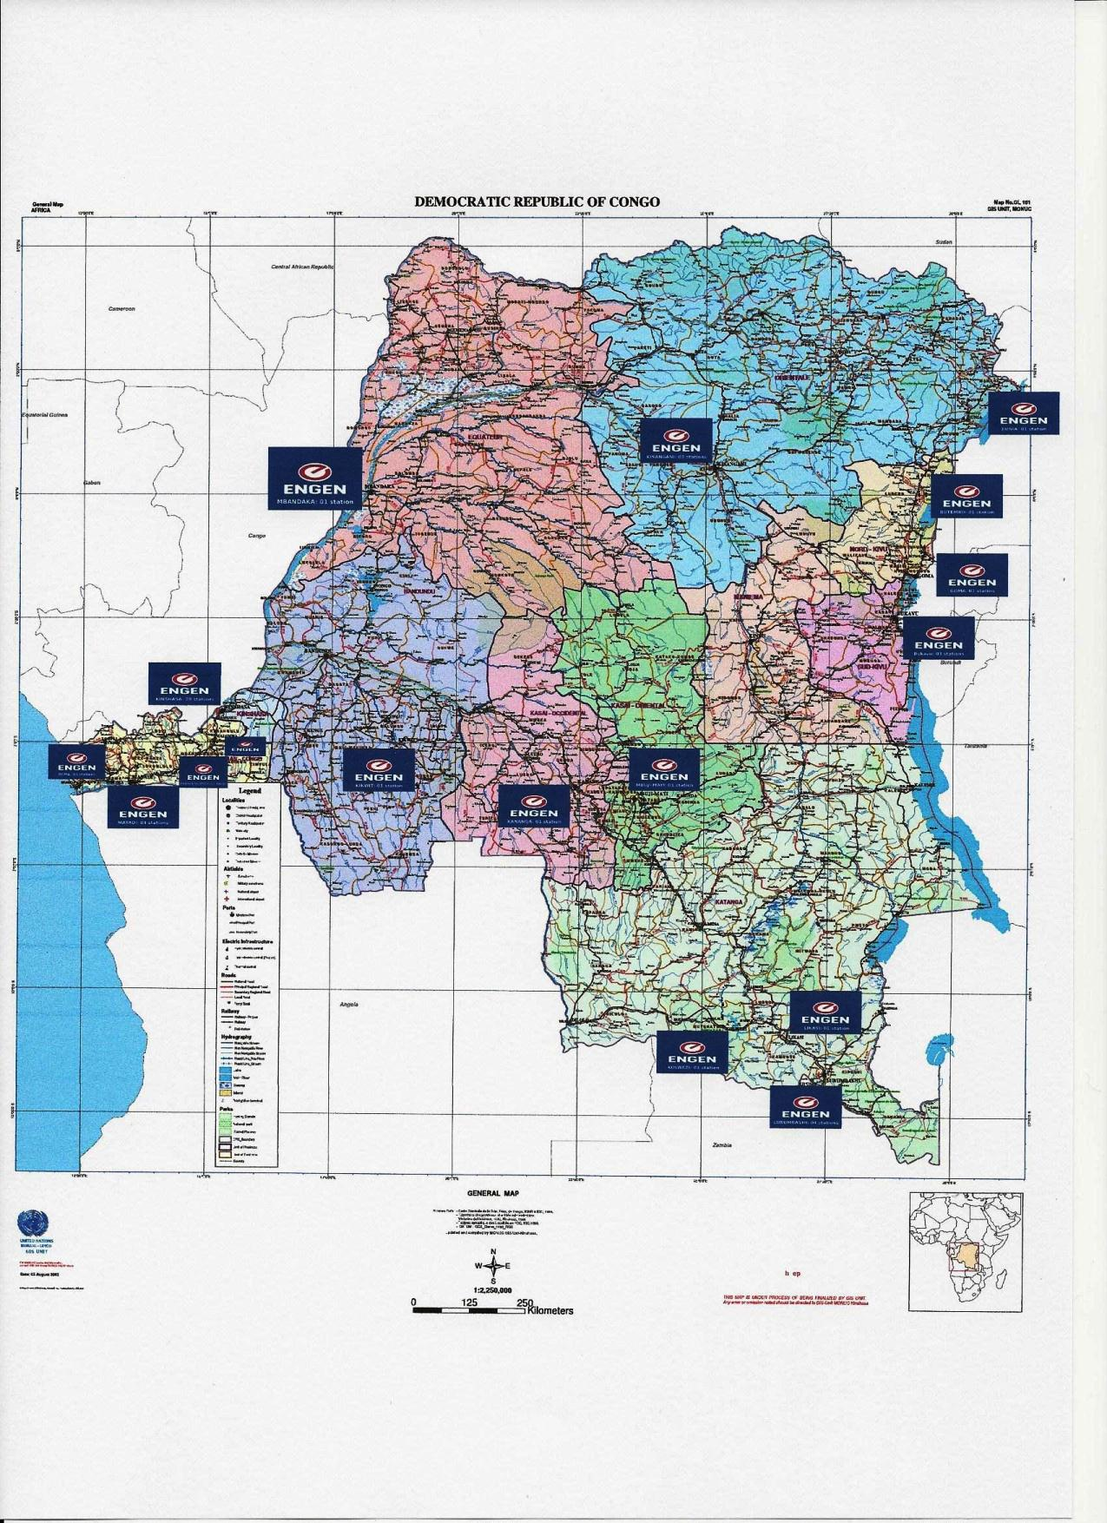

The company operates in three areas: Retail, Aviation and Commercial.

Supply Chain

Our fuel supply chain is in place with proper logistics complying with international transport standards.

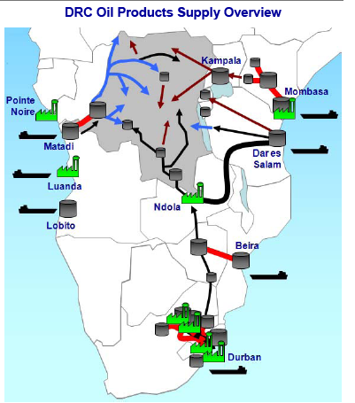

Product Range

- Fuels: Petrol; Diesel; Kerosene
- High Quality Lubricants: Automotive; Hydraulic; Industrial;
- Special Products including environmentally friendly degreaser
- Aviation: Jet A-1
- Others: Fuel oil and Bitumen

Company statement

To be the leader of the distribution of the petroleum products in DRC with
the best quality of service and outstanding standards.

Statistics and Company Focus
- 2010 – Total sales volumes - 290 million Litres.
- 2011 – Total sales volume of 327 million Litres.
- 2012 – Total sales volume of 328 million Litres.
- 2013 – Total sales volume of 325 million Litres.
- 2014 – Total sales volume of 313 million Litres.
- 2015 – Total sales volume of 320 million Litres.
- 2016 – Total sales volume of 293 million Litres.
- 2017– Total sales volume of 298 million Litres.
- 2018 - Total sales volume of 317 million Litres
- 2019 - Total sales volume of 316 million Litres
- 2020 - Total sales volume of 283 million Litres
- 2021- Total sales volume of 399 million Litres
- 2022 Forecast of 505 million Litres.
- Planned investments of more than 8 million USD in service stations and Storage facilities.
- Number one in DRC with a market share of 34%.
- Commercial market share leader with existing supply relationship with the following valued
Customers: BANRO MINING, KISANFU MINING, CHEMAF, RUBACO, RUASHI MINING,PPC, BRALIMA, SNCC, NYUMBA YA AKIBA, SUCRIERE DE KWILU NGONGO, MONUSCO, SN BRUSSELS, SERVE AIR, CAA, KENYA AIRWAYS, and Turkish Airlines.
- Provide a special service of used oils sample analysis in our laboratory in South Africa and a solution for the disposal of waste oil.
- Offer of “ONE CARD” which is an electronic card used to control your fleet fuel consumption. Similar to a credit card it will be easier for your company to save time and money by avoiding theft and loss of time.

One Card: Electronic Card

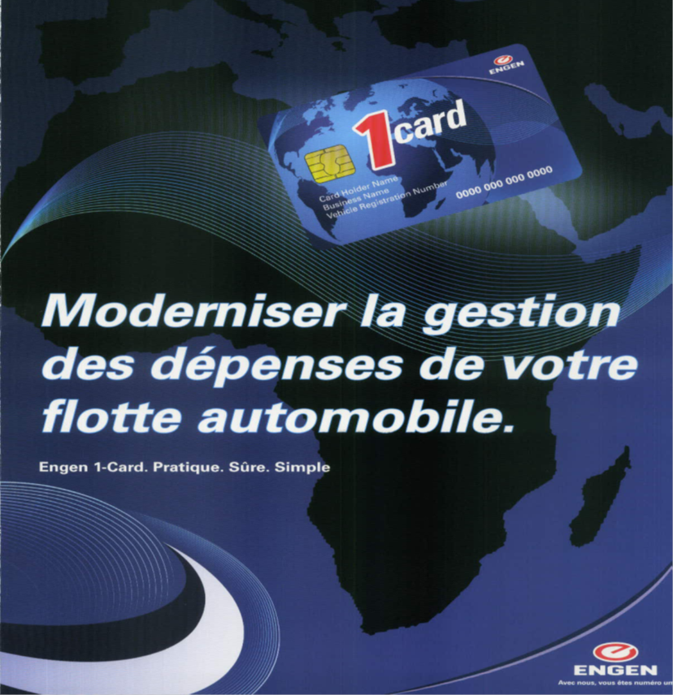

Consolidation: Engen DRC is Number 1

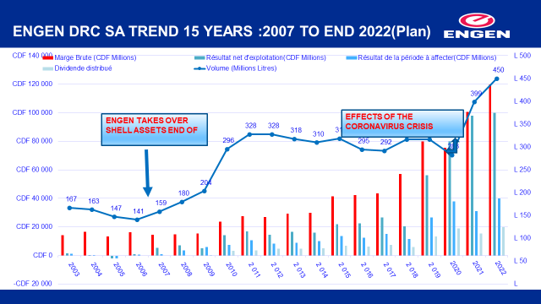

HSEQ

All sites comply with local Health, Safety and Environmental legislation. All our business is done according to high health safety environment quality standards.
Our Health Safety Environment Quality Statement is attached.

Capability

Engen DRC has the facilities, capability and expertise to respond to the fuel and lubricant
needs of the customer.

Engen DRC Organogram

Management and Corporate

COMMERCIAL

Aviation

RETAIL

FINANCE

SUPPLY AND DISTRIBUTION

HUMAN RESOURCES

Engen Values

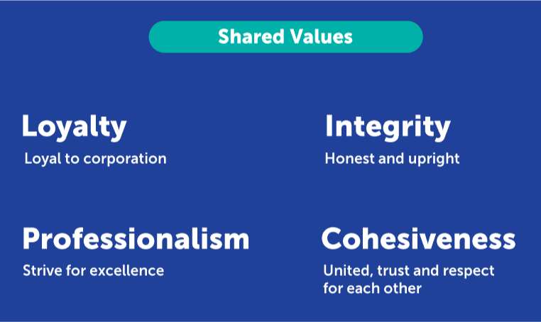

Corporate Social Investment

Engen DRC is involved in Corporate Social Investment.
With the principle of “the best way of living is giving”:
- Financing poorest students for three schools
- Participation in the Health Smile Project
- On the spot interventions such as medical aid after the accident of Sange in Uvira where 230 people were killed by a truck accident due noncompliance to HSE standards.

Project Smile
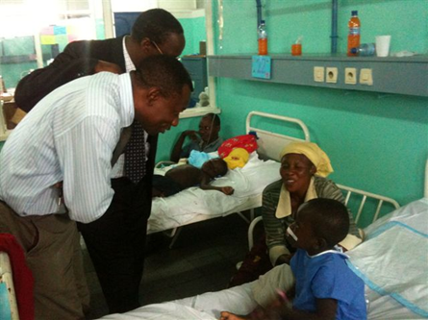
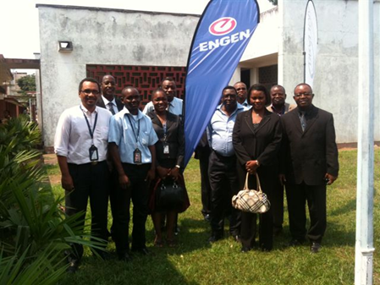

Remise des bombonnes et carburants (one card) et Equipe du Fonds de Lutte Covid-19 :
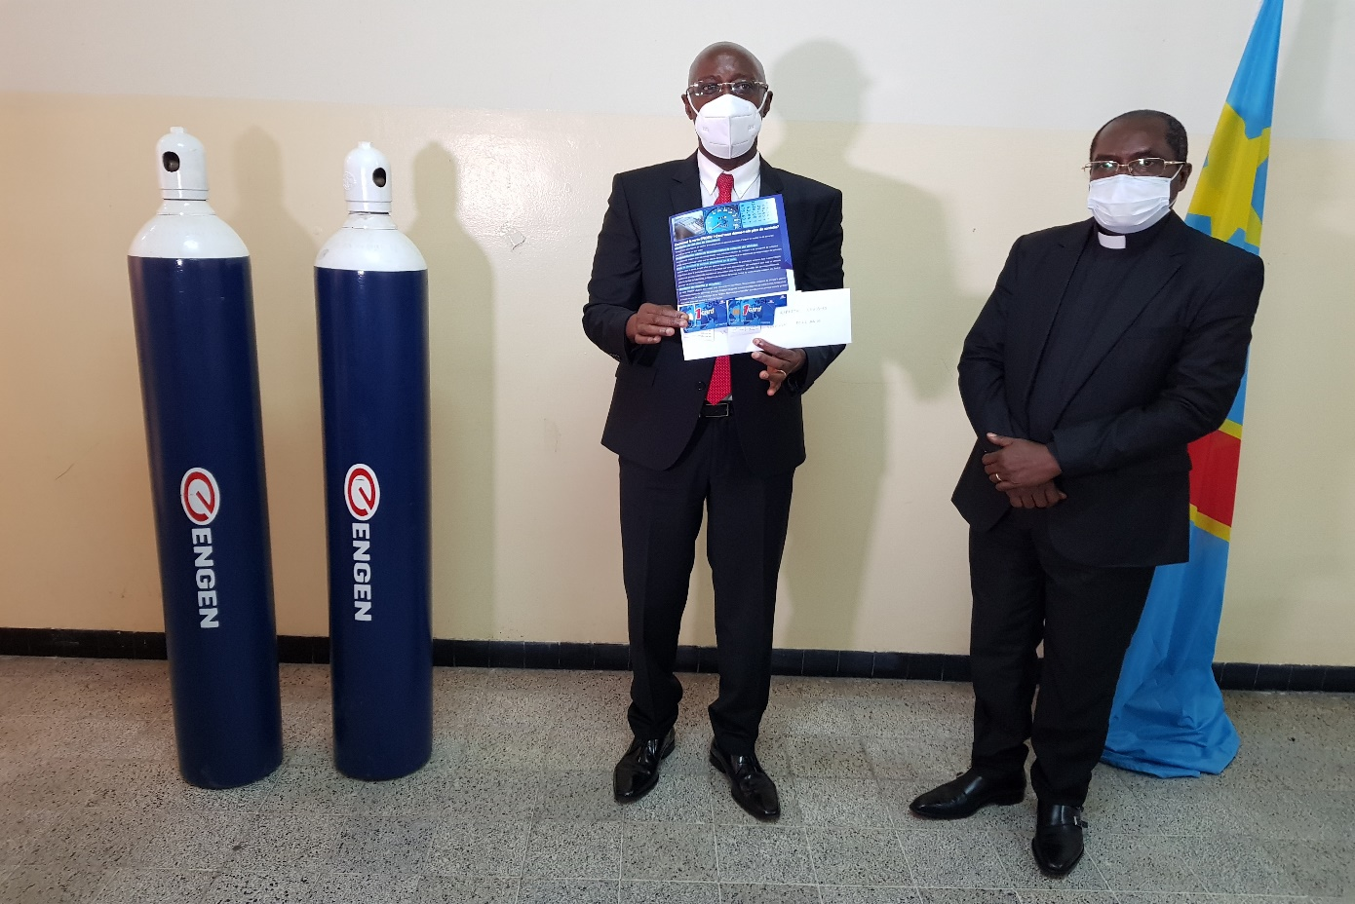

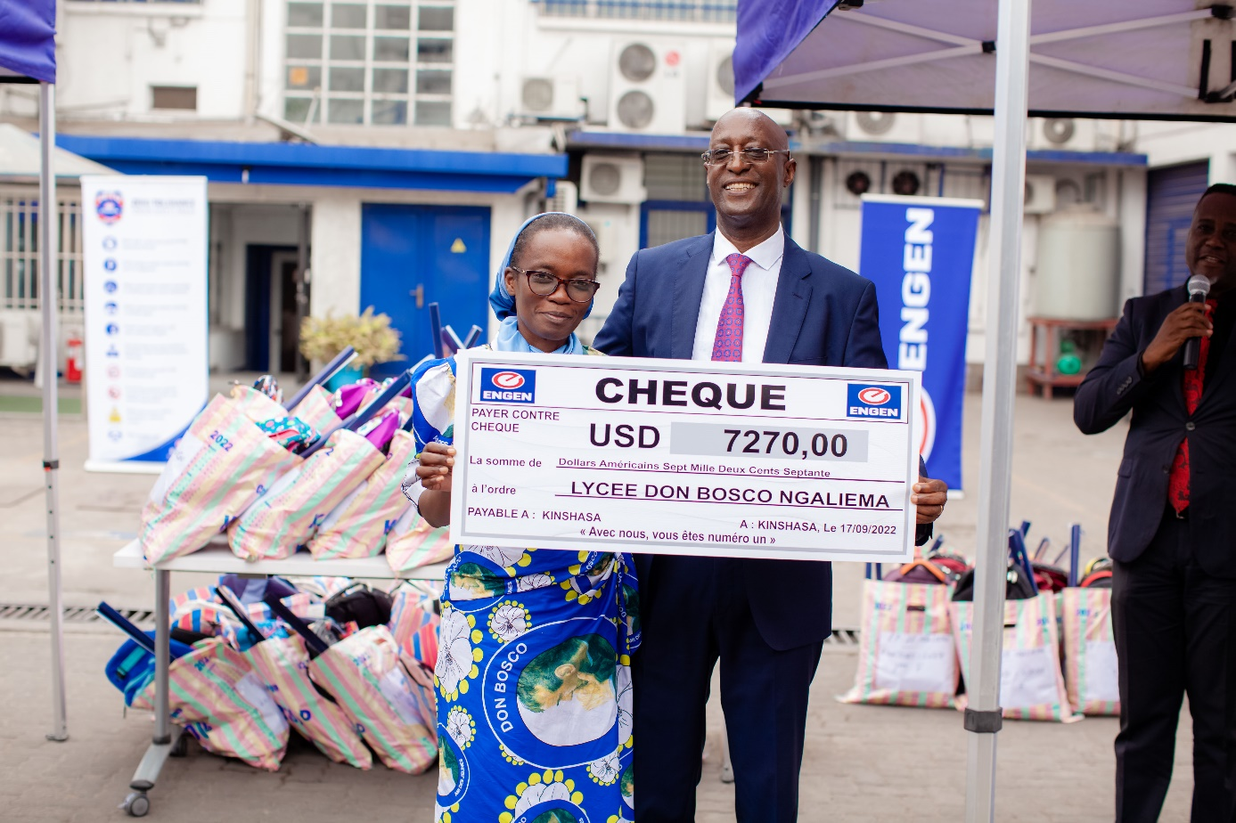

Medical aid - Sange Accident
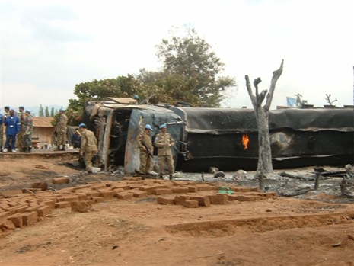
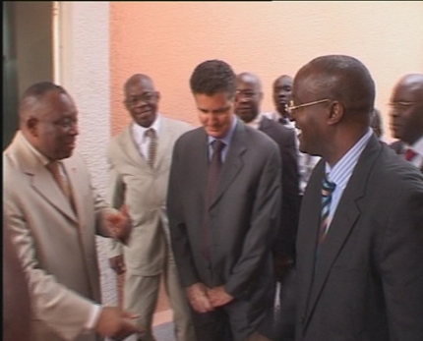

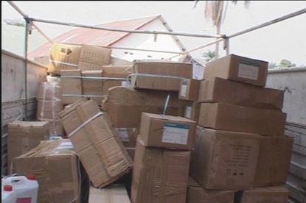

Engen DRC supports scholarships for 61 children in 3 schools

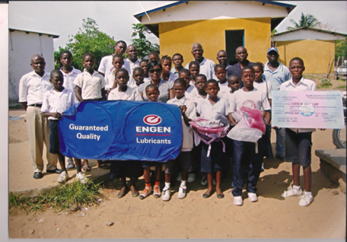
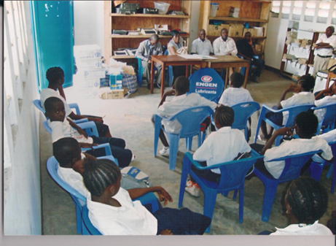
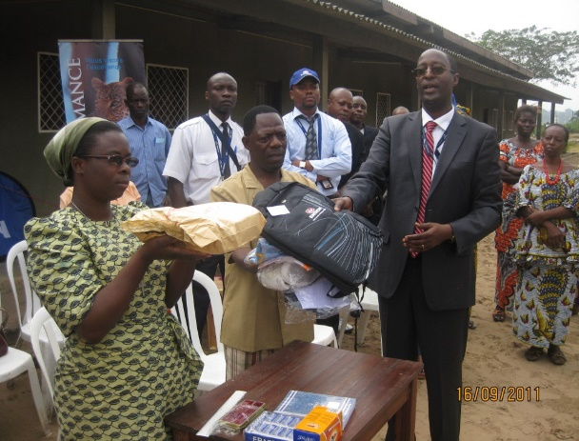
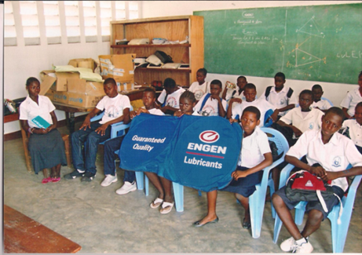

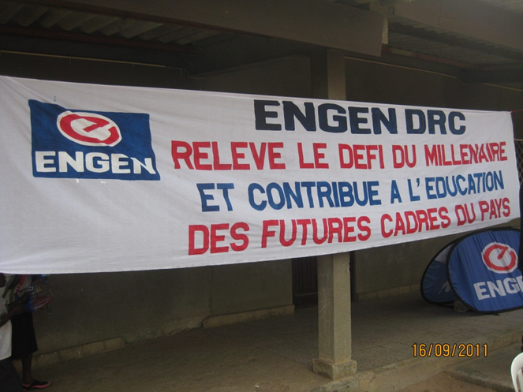

Contacts: ENGEN DRC

Managing Director: ALEXANDRE NGAMBI TITA
Tel: + 243 81 700 55 90
Mobile:+ 243 99 269 62 53
Email: charles.nikobasa@engen.cd

Commercial Manager: Marie-Claire Mubanga
Tel: +243 81 55 65 999; +243 81 55 66 028 (direct)
Mobile: +243 99 99 32 230; +243 81 99 45 001
Email: Marie-Claire.Mubanga@engen.cd

Aviation Manager: Guy Langa
Tel: +243 243 81 55 65 999; +243 81 55 66 046 (direct)
Mobile: + 243 81 810 77 88
Email: Guy.Langa@engen.cd

Company details:

Registre de Commerce et du Crédit Mobilier (RCCM Number): CD/KIN/RCCM 14-B-2649
National Identification: N° 01-923-K12647 G
Kinshasa: 14/16, Av du Port Kinshasa – C/Gombe
Lubumbashi : Carrefour Révolution-Lumumba C/Lubumbashi
Bukavu : Quartier Place Mulamba-Avenue Patrice Emery Lumumba n°237-commune Ibanda

Contact Numbers :
- 0817005590
- 0815553655
- 0812767507
- 0819945001

Email : info@engen.cd

Web site: http://www.engen.cd

LOCAL REFERENCES –Engen DRC

Company Name | Sector | Consumption by month (M3) | Region
KISANFU MINING | Mining | 1 000 | Katanga
Banro ( Twangiza) | Mining | 1 000 | Kivu East
Monusco & Pnud (UNDP) | United Nations | 1 000 | Mainly in Kivu
SOMIKA | Mining | 1 000 | Katanga
Cimenterie de la Lukala (Heidelberg group) | Cement Factory | 2 500 | Bas-Congo
Bralima & Boukin (Heineken group) | Breweries | 1 000 | DRC
SNCC/UPL(world bank project) | Railway Transport | 1 000 | Katanga and west part of DRC
Socitrans | Transport | 800 | Bas-Congo
Gécamines | Mining | 500 | Katanga
SN Brussels | Airline | 1 500 | KINSHASA
CAA | Airline | 1000 | RDC
Serve Air | Airline | 1 800 | GOMA-KISANGANI-LUBUMBASHI-KINSHASA
Turkish Airlines | Airline | 800 | KINSHASA
Ethiopian Airlines | Airline | 600 | KIN-LUBUMBASHI
Kenya Airways | Airline | 200 | KIN-LUBUMBASHI
South African Airways | Airline | 200 | KINSHASA
Chinese Projects Construction (CFHEC,SZTC,CREC 7) | Construction | 900 | West of DRC and Katanga

